**Discussion Document**

Earlier design of the application for Assignment one was not perfect. It lacked many features such as scalability.

I have re-implemented the application using 2 design pattern.

1. Factory Method Pattern

2. Builder Pattern

Description:

1. For creating a Table Item I used **Factory Method** design pattern

Factory: TableItemsFactory.java

Iternface: ITableItems.java

Items: Chairs, CenterPiece, PlaceSetting

Benefit: I can add more types of table Items in future. Also I can change the base prices and number of items in a setting if needed.

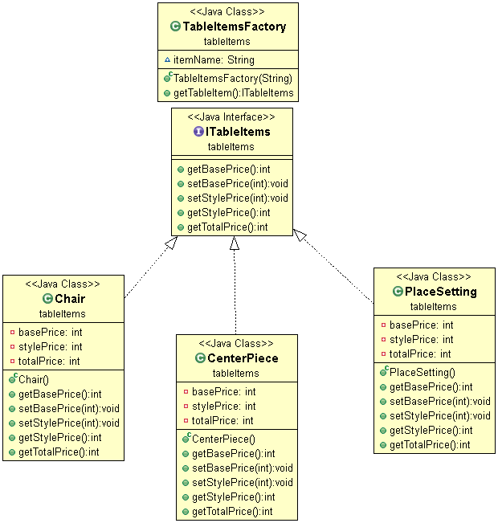

2. For implementing the type of style for a Place setting I used **Builder Design Pattern**

Interface: ITableSetting.java

3 styles: implement the above interface

Modern.java

Vintage.java

Contemporary.java

Benefit: Easier to add more style. Also number of items in a place setting can be modified for every style.

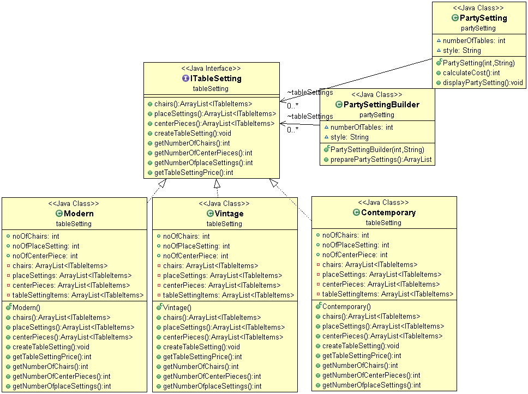

Final UML:

